NEPSE Forecasting Study — Technical Documentation
Nov 8, 2026 · @Rawadeep

Summary
After cleaning 91 million trades and passing a ten-point leakage audit, the calibrated ensembles forecast next-session direction better than chance on the untouched test (59.0% against a 55.3% majority baseline). At 3, 5 and 10 sessions accuracy cannot be told apart from the baseline, and 70% accuracy appears only on a tiny share of calls.
- Data. 91,048,648 trades parsed and 91,009,140 kept (99.957%), after removing 39,500 exact duplicates. Fourteen months of thin floorsheet coverage are handled by taking prices from the OHLCV table. Two sources, the nine single-quarter fundamentals tables and the feature store, were rejected because they leak future information.
- Accuracy. At 1 session, 59.0% (95% interval 57.0–60.9%) against 55.3%, and the ensemble beat its baseline in all six out-of-fold folds. At 3, 5 and 10 sessions it scored 59.2%, 58.3% and 55.3% against baselines of 57.3%, 57.3% and 56.8%, none significant.
- 70% confidence. At confidence ≥ 0.70 the 1-session ensemble was right 81.1% of the time, on 0.40% of stock-sessions (243 calls). The 95% interval, 63.3–85.2%, does not show that accuracy exceeds 70%, and nearly all of those calls are "down" in a falling market.
- Trading. The cross-sectional ranker has a clearly positive rank-IC (0.21–0.28 on the test), but long-only portfolios earn no net return distinguishable from zero after costs, and the ranker's top-10 portfolio loses money at every horizon.
- What a manuscript can claim. Calibrated probability skill at 1 and 3 sessions (test AUC 0.61, Holm p < 0.001 and p = 0.006 against the base rate) and a ranker with positive rank-IC. It cannot claim 70% accuracy, and it should say that the numbers come from scikit-learn stand-ins, not from CatBoost, LightGBM, XGBoost, the Transformer or the TFT, which could not be installed here. Those five families have since been run on a separate 100-stock lite panel; that is a different experiment and none of its figures appear in this document. See "Experiment register and run lineage".

Data sources
The models use the three floorsheet dumps, the adjusted OHLCV table and the quarterly fundamentals table. The nine single-quarter fundamental tables and the feature store were audited and excluded.
File (table) | Contents | Rows | Period | Role
floorsheet_data_part1.zip | Trades: transaction no., symbol, buyer, seller, quantity, rate, amount, date | 41,169,555 | 2018-10-01 – 2024-01-31 | Used: broker features, raw prices, delisted stocks
floorsheet_data_part2.zip | Same schema | 19,364,427 | 2024-02-01 – 2025-01-28 | Used
floorsheet_data_part3.zip | Same schema | 30,514,666 | 2025-02-02 – 2026-11-05 | Used
ohlcv_data.sql (livedata_adjusted) | Daily adjusted OHLCV; NEPSE index and 16 sub-indices | 540,011 (479 symbols) | 1997-07-20 – 2026-11-05 | Used: prices and labels for listed stocks, market features
fundamental_data.sql (new_fundamentals) | Quarterly EPS, P/E, P/B, ROE, D/E, revenue growth | 5,625 reports (270 companies) | FY 2070/71 – 2082/83 | Used: 7 point-in-time features
9 × fundamental_*.sql | Growth, valuation, leverage, liquidity, efficiency, profitability, risk, earnings quality, market performance | 284 each | Latest quarter only | Excluded: one period per company; applying it to past dates leaks future data
nepse_prediction_featurestore.sql | Precomputed features and next-day target | 148,289 (101 symbols) | 2012-02-26 – 2026-11-04 | Excluded: its fundamentals switch before the quarter ends (look-ahead)
All three zips pass CRC and schema checks; their SHA-256 hashes are in the pipeline's data report. Only the floorsheet contains duplicate keys (next section).

Cleaning and de-duplication
Of 91,048,648 trades, 91,009,140 (99.96%) survive cleaning: 39,500 duplicate transactions and 8 invalid rows are removed. De-duplication is global: each trade is filed under the month encoded in its transaction number, so every copy of a transaction meets in the same bucket regardless of which zip it came from.
Check | Rows | Action
Duplicate transaction number | 39,500 (all exact copies, inside part 3, July 2026) | Removed
Quantity, rate or amount ≤ 0 | 8 | Removed
Broker code D01 (dealer account) | 33,758 | Kept as real trades (an earlier version wrongly dropped them)
Older transaction-number format, Oct–Dec 2018 | 102,076 | Kept, flagged
Amount ≠ quantity × rate by more than NPR 1 | 710 | Kept, flagged
trade_time empty | 72,248,755 (79.4%) | Intraday order taken from the transaction number
Daily OHLC violations after aggregation | 0 | —
The clean trades aggregate to 405,370 stock-days (655 symbols, 1,840 sessions), and trade counts reconcile exactly with the daily totals. Storage drops from 7.3 GB of SQL to 2.9 GB of 32-byte binary records in monthly files; the job checkpoints every batch and resumes after an interruption.
The floorsheet itself has gaps. In Feb 2022, Apr 2022 – Mar 2023 and Mar 2024 it holds a median of 20–60 stocks per session, against 220–310 in complete months. The OHLCV table covers those months (190–290 symbols per session), so prices never depend on the gaps; broker features are left missing there rather than imputed.
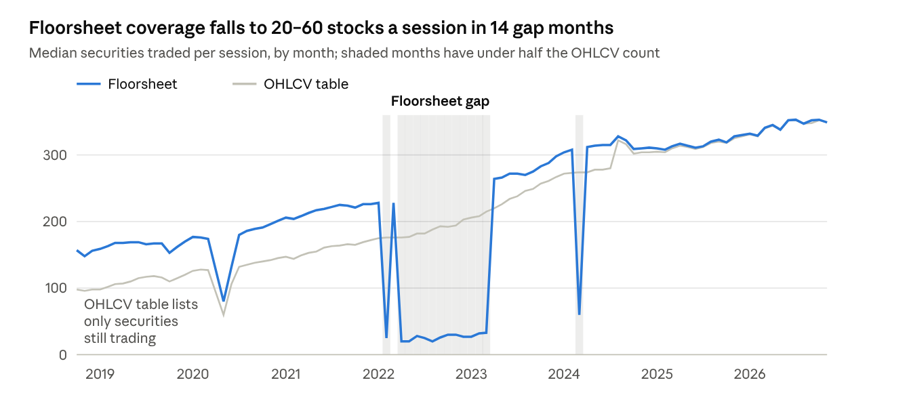
floorsheet daily aggregates and livedata_adjusted · Oct 2018 – Nov 2026
Before 2023 the grey line runs below the blue one because the OHLCV table lists only securities still trading today; that is why the 82 delisted ordinary shares take their prices from the floorsheet.

Universe and prices
The study models 369 ordinary shares, giving 360,943 eligible stock-days across 362 stocks and 1,855 sessions (2018-10-01 – 2026-11-05). Promoter shares (143), debentures and fund series (112) and closed-end mutual funds (30) are excluded.
Security type | Rule | Count | Treatment
Ordinary share, listed | In the OHLCV table | 287 | Back-adjusted OHLCV prices
Ordinary share, delisted or merged (e.g. NCCB, NBB, MEGA, CBL, BOKL) | Only in the floorsheet | 82 | Floorsheet prices; kept to avoid survivorship bias
Promoter share | Listed symbol + "P" or "PO" | 143 | Excluded
Debenture or fund series | Digit or "/" in the symbol | 112 | Excluded
Closed-end mutual fund | Median price below NPR 30 (NAV ≈ NPR 10) | 30 | Excluded
Price construction:
- Adjusted OHLCV is verified, not assumed. Its close equals the raw floorsheet close within 0.5% on 95.9% of days since June 2026 and steps at bonus and rights dates, so it is back-adjusted. Volume is in raw shares.
- Floorsheet prices of delisted stocks are adjusted heuristically: a close-to-close move beyond 11% (the daily limit is ±10%) is treated as a corporate action, and that day's return is replaced by its open-to-close return.
- Chaining. 1,522 floorsheet bars that predate a stock's first OHLCV bar are rescaled to the adjusted basis at the first overlapping day. The scale sets only the price level; every feature and return is scale-free.
- Repairs. 19,433 OHLCV bars whose open or close lay outside the high–low range had high/low widened; 225 residual jumps over 11% among eligible stock-days were neutralised.
- Eligibility uses only the past: traded that session, at least 10 trading days in the last 20, a 60-session return available, and 29 earlier trading days for the sequence model. The session calendar is the union of OHLCV and floorsheet trading days; OHLCV history from June 2017 only warms up rolling windows.

Predictors
The models see 60 predictors per stock-day: 53 core features and 7 point-in-time fundamentals. Each uses only data available at the close of day t; the truncation test in the leakage audit confirms this. Missing values are left missing in the data: gradient boosting splits on them directly; ExtraTrees and logistic regression use training-median imputation; the neural networks use median imputation plus two flags (floorsheet missing, fundamentals missing).
Notation: P = adjusted close; O, H, L = same-day open, high, low; r = daily return; V = share volume; A = floorsheet turnover (NPR); N = number of trades; k = window in sessions. Source: Bars = adjusted OHLCV (floorsheet bars for delisted stocks); FS = floorsheet; IDX = NEPSE index; FUND = quarterly reports.
Feature | Group | Definition | Source | Missing %
ret1, ret2, ret3, ret5, ret10, ret20, ret60 | Return (7) | P(t) / P(t−k) − 1 for k = 1, 2, 3, 5, 10, 20, 60 | Bars | 0.0
vol5 | Volatility | Std. dev. of r over 5 sessions (min. 3 trades) | Bars | 0.1
vol10 | Volatility | Std. dev. of r over 10 sessions | Bars | 0.2
vol20 | Volatility | Std. dev. of r over 20 sessions | Bars | 0.2
vol60 | Volatility | Std. dev. of r over 60 sessions | Bars | 0.4
hl_range | Candle | (H − L) / close | Bars | 0.0
oc_ret | Candle | close / O − 1, clipped to ±20% | Bars | 0.0
close_vwap | Candle | Floorsheet close / floorsheet VWAP − 1 | FS | 11.5
gap | Candle | O(t) / P(t−1) − 1 | Bars | 0.0
close_pos | Candle | (close − L) / (H − L); 0.5 when H = L | Bars | 0.0
ma5_dist, ma10_dist, ma20_dist, ma50_dist | Trend (4) | P / simple moving average over k − 1 | Bars | 0.0
rsi14 | Oscillator | 100 × mean gain / (mean gain + mean loss), 14 sessions | Bars | 0.0
macd_hist | Oscillator | (EMA12 − EMA26 − its EMA9) / P | Bars | 0.0
bb_pos | Oscillator | (P − SMA20) / (2 × SD20) | Bars | 0.0
atr14_pct | Oscillator | Mean true range over 14 sessions / P | Bars | 0.1
stoch_k14 | Oscillator | (P − lowest L) / (highest H − lowest L), 14 sessions | Bars | 0.1
drawdown60 | Range | P / highest P over 60 sessions − 1 | Bars | 0.0
dist_high252 | Range | P / highest P over 252 sessions − 1 (min. 120) | Bars | 3.6
dist_low252 | Range | P / lowest P over 252 sessions − 1 (min. 120) | Bars | 3.6
volratio_1_20 | Liquidity | V(t) / mean V over 20 sessions | Bars | 0.0
volratio_5_20 | Liquidity | Mean V over 5 / mean V over 20 | Bars | 0.0
log_amount | Liquidity | ln(1 + A) | FS | 11.5
log_trades | Liquidity | ln(1 + N) | FS | 11.5
amihud20 | Liquidity | ln(1 + 10^9 × mean of |r| / A over 20 sessions) | FS | 9.2
stale20 | Liquidity | Share of the last 20 sessions with no trade or zero return | Bars | 0.0
turnover_trend | Liquidity | Mean A over 5 / mean A over 20 | FS | 10.6
avg_trade_size | Liquidity | ln(shares traded / N) | FS | 11.5
trades_ratio20 | Liquidity | N / mean N over 20 sessions | FS | 11.8
buyer_hhi, seller_hhi | Broker | Herfindahl index of buying (selling) brokers' volume shares | FS | 11.5
buyer_top1, seller_top1 | Broker | Largest single buying (selling) broker's volume share | FS | 11.5
buyer_top5, seller_top5 | Broker | Top-5 buying (selling) brokers' volume share | FS | 11.5
log_buyers, log_sellers | Broker | ln(1 + number of distinct buying (selling) brokers) | FS | 11.5
self_share | Broker | Share of volume where buying broker = selling broker | FS | 11.5
large_share | Broker | Share of volume in trades of 1,000 shares or more | FS | 11.5
size_cv | Broker | Coefficient of variation of trade size | FS | 11.5
broker_imbalance | Broker | buyer_top5 − seller_top5 | FS | 11.5
buyer_hhi_chg5 | Broker | buyer_hhi − its 5-session mean | FS | 11.8
mkt_ret1 | Market | NEPSE index daily return (equal-weighted universe on the 8 sessions without an index value) | IDX | 0.0
mkt_vol20 | Market | Std. dev. of mkt_ret1 over 20 sessions | IDX | 0.0
rel_ret5 | Market | ret5 − NEPSE 5-session return | Bars, IDX | 0.0
fund_ep | Fundamental | Earnings yield: annualised EPS / quarter-end price × P(quarter end) / P(t) | FUND, Bars | 27.6
fund_bp | Fundamental | Book-to-price: (1 / P/B at quarter end) × P(quarter end) / P(t) | FUND, Bars | 21.1
fund_roe | Fundamental | Return on equity (%), as reported | FUND | 31.0
fund_de | Fundamental | Debt-to-equity, as reported | FUND | 31.7
fund_rev_growth | Fundamental | Revenue growth (%), as reported | FUND | 34.6
fund_eps_yoy | Fundamental | (EPS − EPS of the same quarter a year earlier) / |that EPS|, clipped to ±5 | FUND | 41.5
fund_age | Fundamental | ln(1 + sessions since the report became usable) | FUND | 16.1
Floorsheet features are missing on 11.5% of stock-days, almost all in the floorsheet gap months. A report is usable from quarter end + 45 days and is dropped after 260 sessions without a newer one; P/E and P/B in the table were computed with the quarter-end price (86% of reports match it within 2%), so valuation ratios are rolled forward with the stock's own adjusted return and never use a price after day t.

Targets
Each horizon h ∈ {1, 3, 5, 10} sessions has a binary label: 1 if the adjusted close h sessions ahead is above today's close, 0 if below. Stock-days whose price is exactly unchanged are left unlabelled (5.6% at 1 session, 0.5% at 10), because a tie is neither direction.
y_{i,t}^{(h)} = \mathbf{1}\left[\frac{P_{i,t+h}}{P_{i,t}} - 1 > 0\right], \quad \text{undefined if } P_{i,t+h} = P_{i,t}
Horizon | Labelled stock-days | Share up | Unchanged, excluded | Mean forward return
1 session | 340,322 | 45.5% | 5.6% | 0.08%
3 sessions | 354,301 | 45.7% | 1.6% | 0.23%
5 sessions | 355,809 | 46.2% | 1.0% | 0.38%
10 sessions | 356,498 | 46.6% | 0.5% | 0.77%
Fewer than half the labels are "up", so always predicting "down" already scores 53–55%; every accuracy figure below is compared with that majority baseline in its own test window. The backtest uses a separate tradable return: buy at the next session's open, sell at the close h sessions after today, which removes the closing-price bounce from the profit calculation.

Validation design
Every score in this document is out-of-sample in time. Fold k trains on all stock-days before its block, minus a 25-session embargo (longer than the 10-session label), and is scored on the next 131 sessions (134 in fold 8).
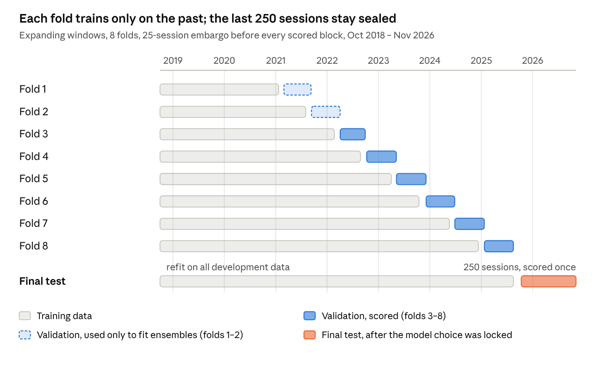
walk-forward validation · 8 folds + final test
Folds 1–2 only feed the ensemble and calibration layers, so every out-of-fold number comes from folds 3–8 (789 sessions). The final test was scored once, after the model choice per horizon was locked and hashed.
Block | Training window | Scored window | Training stock-days | Scored stock-days
Fold 1 | 2018-10-01 – 2021-01-21 | 2021-02-28 – 2021-09-09 | 72,100 | 23,150
Fold 2 | 2018-10-01 – 2021-08-02 | 2021-09-12 – 2022-04-03 | 94,897 | 23,258
Fold 3 | 2018-10-01 – 2022-02-21 | 2022-04-04 – 2022-09-29 | 118,468 | 21,146
Fold 4 | 2018-10-01 – 2022-08-26 | 2022-10-09 – 2023-05-08 | 139,758 | 23,332
Fold 5 | 2018-10-01 – 2023-04-02 | 2023-05-09 – 2023-12-05 | 162,246 | 27,599
Fold 6 | 2018-10-01 – 2023-10-16 | 2023-12-06 – 2024-06-26 | 189,215 | 31,235
Fold 7 | 2018-10-01 – 2024-05-19 | 2024-06-27 – 2025-01-22 | 219,886 | 31,781
Fold 8 | 2018-10-01 – 2024-12-12 | 2025-01-23 – 2025-08-17 | 251,706 | 32,629
Final test | 2018-10-01 – 2025-08-17 (refit) | 2025-10-12 – 2026-11-05 | 290,409 | 64,387

Leakage audit
All 10 checks pass. The strongest is the truncation test: every source was cut at 2024-06-02 (fundamentals by their usable date), the panel was rebuilt, and all 60 features came out identical on all 263,496 earlier stock-days. A centred window, a back-fill or a fundamental used before publication would have changed them.
Check | What it guards against | Result
Embargo covers the label horizon | A training label that resolves inside the validation block | Pass: 25-session embargo, 10-session labels, 16 sessions to spare
Validation blocks tile the period | Overlapping or missing evaluation blocks | Pass: 8 contiguous blocks
First training window | Too little history in fold 1 | Pass: 504 sessions
Final test isolated | Development data touching the test | Pass: 25-session gap; test = 250 sessions, 2025-10-12 – 2026-11-05
Development and test disjoint | A stock-day in both sets | Pass: 290,409 vs 64,387 rows, no overlap
No duplicate stock-sessions | Double-counted rows | Pass
No labels at the series end | Labels built from missing future prices | Pass: 0 labels in the last h sessions
Truncation: same rows | Eligibility depending on future data | Pass: 263,496 / 263,496 rows
Truncation: same features | Any feature using future data | Pass: max difference 0, 0 missing-value mismatches
No suspicious correlation | A feature that is secretly the label | Pass: highest |correlation| with the 1-session label is 0.041 (ret2)
Source-level checks (stage 01b) come first: they rejected the feature store, whose fundamentals switch about 30 days before quarter end, and the nine single-quarter snapshot tables.

Models
The results in this document come from five scikit-learn classifiers and one ranker, each the algorithm its name says. CatBoost, LightGBM, XGBoost, the Transformer and the TFT are implemented in the same pipeline (--family native) but could not be installed in this environment, so they did not produce any number in this document. They were later run on a reduced 100-stock panel in a separate workspace, recorded under "Experiment register and run lineage"; results from that run belong to it, not to the tables here.
Model | Type | Settings | Training rows per fit | Outputs
HistGradientBoosting | Gradient-boosted trees | Learning rate 0.05, 31 leaves, min. leaf 200, L2 = 5, 80% of features per split, up to 1,000 trees; stops after 50 rounds without improvement on the last 12% of training sessions (15-session purge) | All | One model per horizon
ExtraTrees | Randomised tree ensemble | 200 trees, min. leaf 100, 30% of features per split, 50% bootstrap; median imputation | Up to 150,000 (random sample) | One model per horizon
Logistic regression | Linear | L2 penalty, C = 0.1; quantile-to-normal transform; median imputation | All | One model per horizon
MLP | Neural network | Hidden layers 128 and 64, ReLU, Adam (lr 0.001, batch 512, L2 0.001); early stopping, patience 4, at most 40 epochs; median/IQR scaling clipped at ±5 plus 2 missingness flags | Up to 150,000 | One network, 4 horizon outputs
Windowed MLP (sequence) | Neural network on a 20-session window | Same network; inputs = 12 key features over the previous 19 sessions + the current 60 features (290 inputs) | Up to 120,000 | One network, 4 horizon outputs
Ranker | Gradient-boosted regression on ranks | Target = within-session quintile (0–4) of the forward return, sessions with at least 10 stocks; lr 0.05, 31 leaves, up to 400 trees, early stopping | All | One model per horizon; used for ranking (IC), not in the probability ensemble
Every fit sees only stock-days up to its fold's training end. Time order is never shuffled, except inside the MLP's own early-stopping hold-out, which stays within the training period.

Ensembles and calibration
The five classifiers' probabilities are combined four ways, and every combination and base model is also calibrated two ways, giving 12 ensemble candidates per horizon (27 with the calibrated base models). Nothing is fitted on the rows it is scored on: each layer learns only from earlier folds.
Ensemble | Rule
Average | Mean of the five probabilities
Weighted | Non-negative weights summing to 1 that minimise log-loss on earlier folds
Stacking | Logistic regression on the five log-odds, fitted on earlier folds
Regime-aware stacking | A separate stacker for each of 4 market regimes (NEPSE 60-session return up/down × 20-session volatility above/below its median), falling back to the global stacker when a regime has fewer than 3,000 rows
p_{\text{stack}} = \sigma\!\Big(\beta_0 + \sum_{m=1}^{5} \beta_m \,\operatorname{logit} p_m\Big), \qquad p_{\text{Platt}} = \sigma\big(a + b \operatorname{logit} p\big)
Isotonic calibration fits a monotone step function (pool-adjacent-violators), clipped to [0.005, 0.995].
Nested walk-forward order:
- Base models produce out-of-fold probabilities for folds 1–8.
- For fold k, ensemble weights and stackers are fitted on folds before k (minus the 25-session embargo), giving ensemble outputs for folds 2–8.
- For fold k, Platt and isotonic calibrators are fitted on ensemble outputs from folds 2 to k−1, giving calibrated outputs for folds 3–8.
- All out-of-fold comparisons use folds 3–8 (Apr 2022 – Aug 2025), where every candidate exists.
- For the final test, the candidate with the lowest out-of-fold log-loss is chosen per horizon and its name is hashed into a lock file before any test prediction is scored.

Prediction accuracy
On the untouched 250-session test, only the 1-session forecast beats the majority baseline with confidence: 59.0% against 55.3%, with a 95% interval of 57.0–60.9%. The 3-, 5- and 10-session forecasts cannot be told apart from always predicting the majority class.
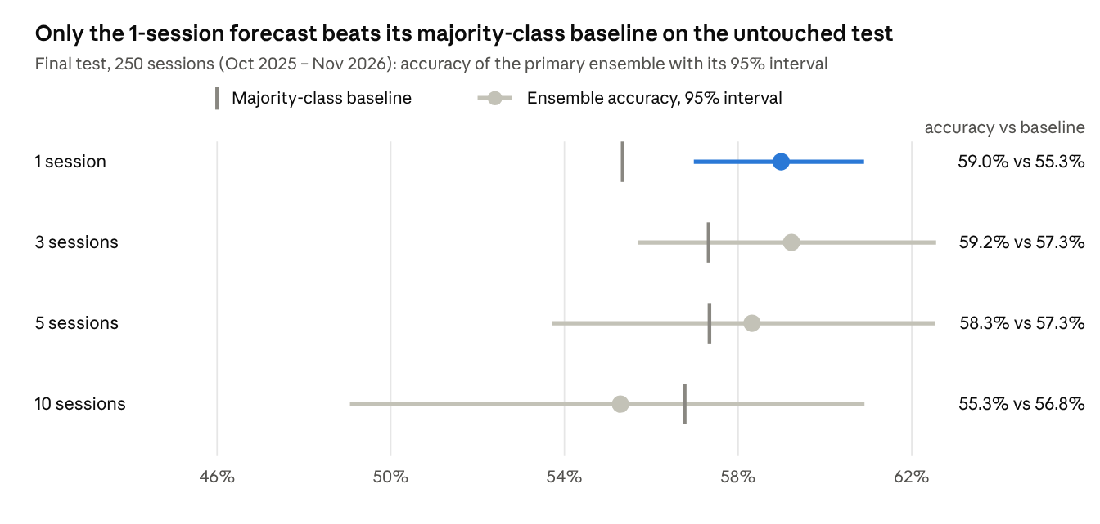
stage 12 final test · primary ensemble (weighted) · 1,3,5,10-session horizons · scikit-learn model family
The majority class is "down" at every horizon, in the out-of-fold folds and on the test (1-session up-rate on the test: 44.7%), so the baseline is 54–57%, not 50%. Out-of-fold, the 1-session ensemble beat its baseline in all six scored folds; the 3-session ensemble beat it in one fold, and the 5- and 10-session ensembles in none.
Horizon | Out-of-fold accuracy vs baseline | Folds beating baseline | Out-of-fold AUC | Test AUC | Test ECE | p(test accuracy > baseline)
1 session | 57.1% vs 54.8% | 6 of 6 | 0.579 | 0.608 | 0.032 | < 0.001
3 sessions | 54.1% vs 54.5% | 1 of 6 | 0.535 | 0.610 | 0.049 | 0.144
5 sessions | 52.8% vs 54.1% | 0 of 6 | 0.525 | 0.597 | 0.062 | 0.317
10 sessions | 52.3% vs 53.8% | 0 of 6 | 0.521 | 0.584 | 0.073 | 0.685
Out-of-fold results cover folds 3–8 (789 sessions, 163,000–167,000 labelled rows per horizon). Test AUC is higher than out-of-fold AUC at every horizon. Either the final models had more training data or the test window was easier; one window cannot separate the two.

Model comparison
The ensembles were chosen on out-of-fold log-loss before the test was scored, and the weighted ensemble won at every horizon. On the test, a single HistGradientBoosting model has the highest AUC at 3 to 10 sessions, but it was not selected in advance, so it is shown here only for comparison.
Model | AUC, 1 session | AUC, 3 sessions | AUC, 5 sessions | AUC, 10 sessions
Weighted ensemble (primary) | 0.608 | 0.610 | 0.597 | 0.584
Simple average | 0.585 | 0.591 | 0.586 | 0.584
Stacking | 0.607 | 0.604 | 0.590 | 0.580
Regime-aware stacking | 0.595 | 0.577 | 0.545 | 0.536
HistGradientBoosting | 0.606 | 0.629 | 0.607 | 0.609
ExtraTrees | 0.586 | 0.583 | 0.582 | 0.586
Logistic regression | 0.558 | 0.546 | 0.526 | 0.505
MLP | 0.561 | 0.563 | 0.562 | 0.561
Windowed MLP | 0.536 | 0.540 | 0.539 | 0.545
The tree models carry the signal and the neural networks add little. The two MLPs are badly calibrated before recalibration (ECE 0.11–0.24 on the test), which is why they gain the most from Platt and isotonic scaling. The full table for all 27 candidates at each horizon is in research_report.md.

Cross-sectional ranker
The ranker orders stocks within each session instead of calling direction. Its rank correlation with realised returns is clearly positive at every horizon, although it shrinks as the horizon lengthens.
Horizon | Out-of-fold rank-IC | Test rank-IC (HAC t) | Test top-minus-bottom quintile return | Test top-decile up-rate
1 session | 0.206 | 0.284 (37.5) | 1.02% | 58.6%
3 sessions | 0.173 | 0.270 (24.2) | 1.45% | 55.8%
5 sessions | 0.142 | 0.248 (15.0) | 1.67% | 53.0%
10 sessions | 0.105 | 0.213 (8.6) | 2.04% | 51.8%
The spread is a long-short quantity, and NEPSE retail investors can only go long. The Backtest section shows that the long-only version loses money after costs.

70% confidence
A 70% accuracy is reachable only by acting on a tiny share of calls. At confidence ≥ 0.70, the 1-session ensemble was right 81.1% of the time on the test, but that is 243 calls, 0.40% of all stock-sessions, and the 95% interval runs from 63.3% to 85.2%.
A call is made when the larger of P(up) and P(down) reaches the threshold. Each cell below shows accuracy, then coverage (the share of all stock-sessions that receive a call).
Horizon | ≥ 0.55 | ≥ 0.60 | ≥ 0.65 | ≥ 0.70 | Out-of-fold ≥ 0.70 [95% interval]
1 session | 64.0% (50.1%) | 69.6% (16.1%) | 72.0% (2.9%) | 81.1% (0.40%) | 71.3% (1.2%) [62.3%, 78.3%]
3 sessions | 66.5% (38.4%) | 74.5% (7.2%) | 83.6% (0.66%) | 100% (0.03%, 22 calls) | 68.5% (0.37%) [57.8%, 79.3%]
5 sessions | 65.0% (25.8%) | 64.3% (2.2%) | 83.7% (0.08%, 49 calls) | no calls | 49.4% (0.29%) [37.9%, 68.3%]
10 sessions | 59.0% (28.5%) | 62.9% (2.3%) | 68.6% (0.06%, 35 calls) | 1 call, wrong | 53.3% (1.47%) [25.3%, 74.1%]
The first four columns are the untouched test. Four things limit what the table can support.
- Almost every confident call is "down". In the out-of-fold 1-session stack, over 99% of calls at ≥ 0.70 predicted a fall, in a market where 55% of outcomes were down anyway.
- Small counts. The 100% at 3 sessions rests on 22 calls, so its interval says nothing. The 5- and 10-session ensembles make almost no calls at ≥ 0.70, and none of them were accurate.
- 70% is not shown to be exceeded. The one-sided block-bootstrap test of "accuracy above 70%" gives p = 0.407 out-of-fold and p = 0.149 on the test for 1 session, so neither rejects an accuracy of 70% or less.
- Selection. Four thresholds at four horizons are sixteen looks. The thresholds were fixed before scoring, but the best-looking cell is still the best of sixteen.

Calibration
The weighted ensemble is already close to calibrated before any rescaling: ECE is 0.008 out-of-fold and 0.032 on the test at 1 session. Platt scaling and isotonic regression, fit only on earlier folds, change little there (test ECE 0.027 and 0.021; log-loss 0.6720 to 0.6715 and 0.6707). At 5 and 10 sessions they pull every probability toward the base rate, so calibrated forecasts almost never pass 0.55 and every call defaults to the majority class. Their accuracy then equals the baseline exactly (57.3% and 56.8%), which is calibration working as intended on a model with little signal.
The test reliability curve shows the 1-session ensemble is slightly under-confident at the top: stock-sessions forecast at P(up) near 0.62 rose 77% of the time (982 observations). The curve for every horizon is in research_report.md.

Significance
The ensemble's probabilities beat the base rate at 1 and 3 sessions on the test, but not at 5 or 10 sessions, and its edge over a single model or a simple average is detectable only at 1 session.
Each cell is the mean log-loss advantage of the weighted ensemble (positive means the ensemble is better) with the Holm-corrected one-sided p-value from a Diebold–Mariano test on session-level losses, using a heteroskedasticity- and autocorrelation-consistent (HAC) variance whose lag is the horizon-dependent max(h, 5) + 5 sessions (10 for 1 to 5 sessions, 15 for 10).
Horizon | vs base rate (climatology) | vs best single model by out-of-fold loss (ExtraTrees) | vs simple average
1 session | +0.0145 (p < 0.001) | +0.0066 (p = 0.0002) | +0.0053 (p = 0.019)
3 sessions | +0.0105 (p = 0.006) | +0.0060 (p = 0.001) | +0.0039 (p = 0.87)
5 sessions | +0.0041 (p = 1.00) | +0.0032 (p = 0.35) | +0.0041 (p = 1.00)
10 sessions | −0.0004 (p = 1.00) | −0.0003 (p = 1.00) | +0.0082 (p = 1.00)
Three readings follow from the table and the out-of-fold tests.
- Probability skill is wider than accuracy skill. At 3 sessions the ensemble beats the base rate in log-loss (Holm p = 0.006) although its accuracy is not distinguishable from the baseline (p = 0.144), because accuracy only counts which side of 0.5 a forecast falls on.
- Out-of-fold, only 1 session passes. The 1-session ensemble beat the base rate (Holm p = 0.0001) but not the best single model or the simple average after correction (Holm p = 0.74 and 1.00). The 3-, 5- and 10-session ensembles did not beat the base rate out-of-fold.
- The ensemble earns its place at 1 session. On the test it beats the best single model and the simple average at 1 session, and the best single model at 3 sessions, after correction. At 5 and 10 sessions nothing separates the candidates.
Intervals and p-values for accuracy and coverage come from a session-block bootstrap, which resamples whole sessions so that stocks traded on the same day stay together (1,000 draws on the test, 300 out-of-fold). The Holm correction runs over the full set of comparisons at each horizon, so a result that survives it is not the best of many looks.

Drivers
Two features that describe the whole market, the NEPSE index's 1-session return and 20-session volatility, matter most at every horizon, and fundamentals take over at 5 and 10 sessions.
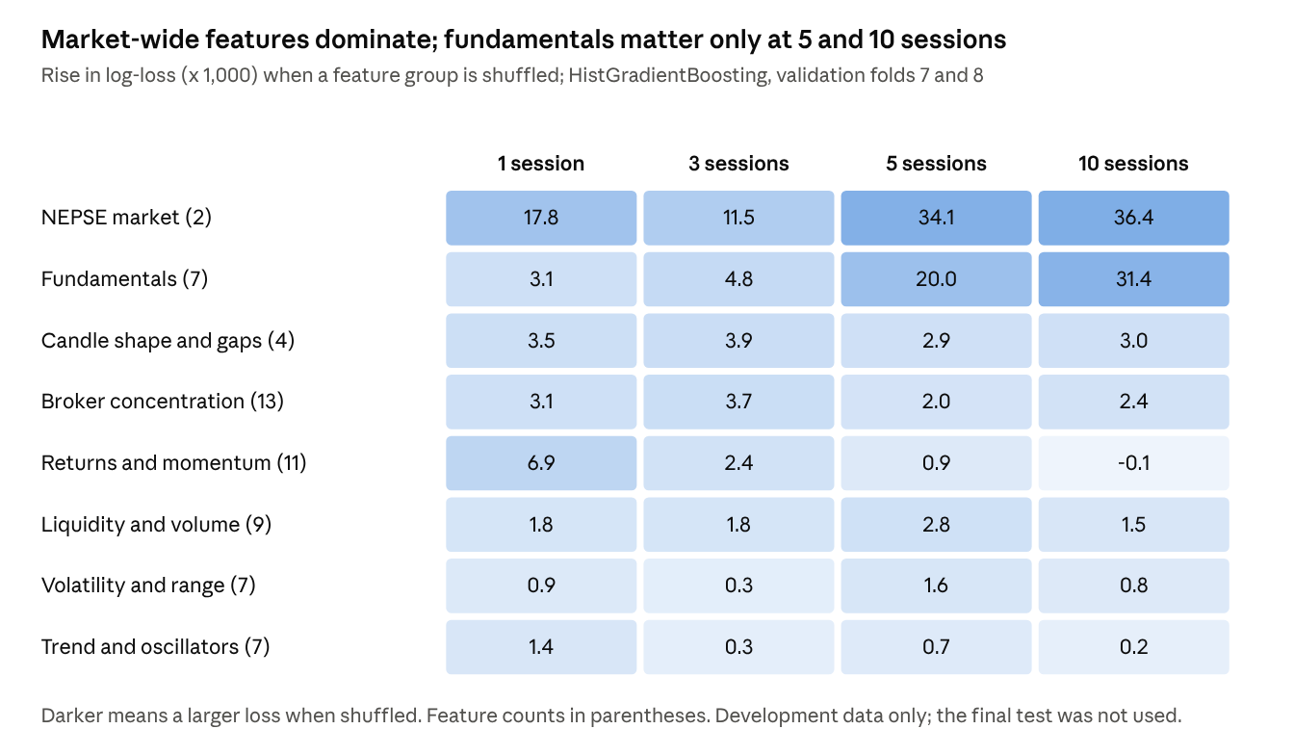
grouped permutation importance · HistGradientBoosting refit on folds 7 and 8, development data only · 2 shuffles per group
These are model dependencies, not causes. Shuffling a group measures how much one HistGradientBoosting model loses without it, on the two latest validation folds, so correlated groups can share credit. Two cautions apply:
- Market features act as a regime label. They take the same value for every stock in a session, so a tree can use them to recognise the period. The 1-session forecast leans on them less (loss rises 0.018) than the 5- and 10-session forecasts (0.034 and 0.036).
- Fundamentals change only quarterly. Their weight at 10 sessions (0.031) may reflect slow differences between stocks, or the period, rather than information the market has not already priced. The ablation in run_pipeline.sh (NEPSE_FEATURESET=core) isolates this; it has not been run here.
At 1 session the signal is spread thinly: returns and momentum (0.0069), candle shape and gaps (0.0035), broker concentration (0.0031) and fundamentals (0.0031) each add a little, and the market-wide pair adds the most (0.0178). No single stock-level group dominates at any horizon.

Backtest
No long-only strategy earns a net return that differs from zero. Portfolios built on confident "up" forecasts beat random stock picks at 1, 3 and 10 sessions but lose or barely earn after costs, and the ranker's top-10 portfolio loses money at every horizon.
The backtest runs on the untouched test. At the close of a session it buys, equal-weight and up to 10 liquid names, those whose calibrated P(up) reaches the threshold. It enters at the next session's open, exits at the close of session t + h, and deploys 1/h of capital per signal session. Costs per side are 0.36% commission, 0.015% SEBON fee and 0.10% slippage, about 0.95% round trip, plus 7.5% short-term capital-gains tax on profitable trades. Signals in names that do not trade the next session are counted as unfilled (fill rate 90–97%).
Horizon (P(up) ≥ 0.60) | Trades | Mean gross per trade | Mean net per trade [95% interval] | Hit rate | Random picks, mean net | Cumulative return | Sharpe | Max drawdown
1 session | 410 | +0.81% | −0.20% [−0.56%, +0.20%] | 41.2% | −0.65% | −27.0% | −1.31 | −29.8%
3 sessions | 244 | +1.65% | +0.55% [−0.25%, +1.41%] | 50.4% | −0.37% | +8.2% | 0.72 | −12.1%
5 sessions | 128 | +0.94% | −0.15% [−1.98%, +1.44%] | 36.7% | −0.43% | −2.1% | −0.55 | −5.7%
10 sessions | 409 | +1.64% | +0.52% [−1.01%, +2.21%] | 50.4% | −0.27% | +5.2% | 1.62 | −3.7%
Random picks are drawn from the same sessions with the same number of names per session (300 draws). The strategy beats them at 1, 3 and 10 sessions (no random draw did as well in 300) and at 5 sessions does not (p = 0.17). Random picks lose 0.3–0.7% a trade because costs exceed the average gross return, so beating them is a low bar. Every interval for the strategy's net return includes zero.
- Confident forecasts cannot be traded long-only. Almost all of the confident calls behind the 70% table are "down" calls. A long-only investor can act only on "up" calls, and there are few of them: at P(up) ≥ 0.70 there were 7 signals at 1 session and none at 3, 5 or 10, so no portfolio was run at that threshold.
- The ranker earns a gross edge that costs erase. The top-10 portfolio makes +0.47%, +0.62%, +0.61% and +0.67% gross per trade at 1, 3, 5 and 10 sessions, and −0.53%, −0.41%, −0.43% and −0.40% net. Cumulative returns are −72.4%, −26.8%, −17.2% and −8.6%, and the net per-trade loss is significant at 1 and 3 sessions. Its quintile spread needs a short leg that NEPSE retail investors do not have.
- Costs dominate at short horizons. Every 1-session trade pays the full round-trip cost, which is why the 1-session portfolio, the one with the best forecasts, is the worst performer.

Experiment register and run lineage
The five native libraries that could not be installed when this study was run — XGBoost, LightGBM, CatBoost, the Transformer and the TFT — have since been run in a separate environment on a reduced panel. A file register compiled on 9 November 2026 inventories everything produced so far: 555 records, made up of 208 files inside the six execution workspaces, 33 loose files and 314 members of ZIP archives. This section records which run produced what, so that no figure is read against the wrong experiment.

Run lineage
- Full-panel scikit-learn baseline — this document. nepse_pipeline/, nepse_pipeline_resume/, nepse_pipeline.zip and nepse_results.zip. Five scikit-learn classifiers and one ranker over the full 362-stock panel. Every accuracy, calibration, significance, driver and backtest figure in this document comes from this run and from no other.
- Early native lite work. nepse_native_lite_work/ holds a seven-family out-of-fold object for folds 1–8 with early ensemble and statistical outputs. Superseded by the combined run below.
- Native tree branch. nepse_native_tree_lite_run/ holds the XGBoost, LightGBM, CatBoost and logistic out-of-fold outputs, the training log, the panel, the split manifest and stage reports.
- Native sequence and ranker branch. nepse_native_seq_ranker_lite_run/ holds the Transformer, TFT-style and LambdaRank out-of-fold and final-test outputs, saved models and feature diagnostics.
- Combined native seven-model run. nepse_native_all_models_lite_run/ merges all seven native families into one set of out-of-fold predictions, with the selected ensemble, calibration, statistics, final-test scoring, saved final models, the source panel, the scripts and its own report.
- Standalone refits. The CatBoost and XGBoost/LightGBM bundles preserve per-horizon refit results, logs, summary tables and training scripts from before the combined run.
The native runs are a different experiment, not an update to this one. They use a 100-stock lite panel; the results in this document use the full 362-stock panel. The model families differ and the universe differs, so rows from the two must never appear in one table without naming the run that produced each. No native figure is quoted anywhere in this document.

Execution workspaces
Workspace | Files | Stored size | Contents
nepse_native_all_models_lite_run/ | 88 | 158.5 MB | Latest merged native seven-model lite-panel run: out-of-fold predictions, ensemble and calibration, statistics, final-test metrics, saved final models, scripts, source panel and research report.
nepse_native_seq_ranker_lite_run/ | 60 | 129.7 MB | Earlier Transformer / TFT-style / LambdaRank branch: sequence and ranker outputs, models, feature diagnostics, reports and scripts; also some stale process-ID marker files.
nepse_native_tree_lite_run/ | 8 | 67.8 MB | Earlier tree branch: XGBoost, LightGBM, CatBoost and logistic out-of-fold outputs, training log, panel, split manifest and stage reports.
nepse_native_lite_work/ | 11 | 130.8 MB | First combined native attempt. Its out-of-fold object already covers all seven families, but it predates the merged bundle.
nepse_pipeline/ | 21 | 212 KB | Source of the pipeline described in this document: ingestion, auxiliary sources, panel, audit, models, ensemble, statistics, final test, backtest export and feature importance.
nepse_pipeline_resume/ | 20 | 165 KB | Resumed copy of the same source tree, including the model, backtest and reporting scripts.

Packages and reports
Package or document | What it is
nepse_native_all_models_lite_bundle.zip (82.3 MB, 88 entries) | Complete combined native seven-model lite-panel bundle.
nepse_native_all_models_lite_results.zip (195 KB, 34 entries) | Compact reports, metrics and logs for the same run.
research_report_native_all_models_lite.md (12.8 KB) | Narrative report for the combined native run, with its own addendum file.
nepse_native_sequence_ranker_lite_bundle.zip (69.3 MB) | Earlier sequence and ranker bundle, with a compact results package beside it.
nepse_catboost_completed_bundle.zip (24.3 KB, 17 entries) | Standalone CatBoost refit: per-horizon results, logs and the training script.
nepse_xgb_lightgbm_run_bundle.zip / …_spec_refit_bundle.zip | XGBoost and LightGBM first run and specification-aligned refit, with summary CSVs.
nepse_results.zip (268 KB) and nepse_pipeline.zip (57.5 KB) | Stage reports, figures and source for the baseline run documented here.
NEPSE_COMPLETE_MODEL_EXECUTION_FILE_REGISTER.csv | The register itself: 555 rows of record type, container, path, byte size and description.

What the combined native run holds
- oof.pkl — merged out-of-fold predictions for XGBoost, LightGBM, CatBoost, logistic regression, the Transformer, the TFT-style model and LambdaRank; ens_oof.pkl — ensemble and calibration outputs; test_predictions.pkl — final-test predictions with row and session metadata.
- models/ — saved final models per horizon in each library's own format (.json for XGBoost, .cbm for CatBoost, .txt for LightGBM and the ranker, .pt for the Transformer and TFT, .joblib for logistic regression and the second-level models).
- reports/ — stage reports, candidate metric tables for out-of-fold and final test, bootstrap and Holm results, ranker statistics and feature-group diagnostics.
- scripts/, source/TRAINING_SPEC.md and source/nepse_model_panel_lite.csv.gz — the code and the exact panel the run read, so the run can be repeated without rebuilding the panel.
- splits.json, selection.json, final_test.lock, environment.txt, RUN_STATUS.json and CHECKSUMS.sha256 — the fold manifest, the pre-test selection and its hash, the dependency snapshot, the completion record and the integrity manifest.

Reading the register
- Duplicates are deliberate. The same artifact is copied into several bundles; a repeated path is a package copy, not a separate run.
- Integrity. The combined run's CHECKSUMS.sha256 was verified for all 87 payload files when that bundle was built. The register covers workspaces and archives beyond that bundle, which carry no such manifest.
- Stale markers. The older sequence and ranker workspace still contains .pid files. They record process IDs from finished runs and are not restart instructions.
- An inventory is not a result. Listing a run does not make it complete, statistically independent of the others, or deployable; the runs share a panel and overlap heavily in their folds.

Limitations and threats to validity
The numbers in this document describe one market, one final-test window and a stand-in model family; read them as a clean baseline, not as a deployable edge.
- Stand-in models. CatBoost, LightGBM, XGBoost, the Transformer and the TFT never ran here, because package installs were blocked. Every result comes from scikit-learn models: HistGradientBoosting, ExtraTrees, logistic regression, an MLP, a 20-session windowed MLP and a pointwise HistGradientBoosting ranker. FAMILY=native START=6 bash run_pipeline.sh reruns stages 6–13 with the named libraries, and that is how the separate native lite-panel run was produced; because that run uses 100 stocks rather than 362, it does not replace the figures here.
- Floorsheet gaps. In 14 months (Feb 2022, Apr 2022 – Mar 2023, Mar 2024) the floorsheet holds only 20–60 stocks a session. Prices stay complete because they come from the adjusted OHLCV table, but broker and trade-size features are missing there (present for 29.2% of 2022 samples) and validation folds 3 and 4 fall almost entirely inside the gap.
- Base rate. Only 45.5–46.6% of labelled outcomes are up, so a model that leans toward "down" beats a coin flip without skill. Every accuracy is therefore shown against the majority-class baseline of the same window.
- Overlapping labels. For 3, 5 and 10 sessions, neighbouring labels share most of their return path, so the effective sample is far smaller than the row count. The 25-session embargo, the session-block bootstrap and HAC-corrected Diebold–Mariano tests account for this; a plain binomial interval would be too narrow.
- Confidence threshold. Thresholds of 0.55–0.70 were fixed before scoring, but four thresholds across four horizons are still sixteen looks. A 70% cut-off selects the most confident calls; it does not make the model 70% accurate overall, and its coverage is small.
- Publication lag. Fundamentals are used from quarter end + 45 days. That lag is an assumption, since none of the fundamentals tables records when a report was published.
- Survivorship. The OHLCV table lists only symbols still trading; 82 delisted ordinary shares use floorsheet prices. Companies delisted before October 2018 are absent altogether.
- Price jumps and flat outcomes. Residual moves above 11% (the circuit limit is 10%) were neutralised on 225 symbol-sessions, and flat outcomes (0.5–5.6% of rows by horizon) have no direction label, so they are excluded.
- Execution. The backtest enters at the next open with 10 bp slippage per side and no market impact. Thin names may fill worse, and the strategy is long-only because retail investors on NEPSE cannot short.

Reproducibility
The whole study reruns from the source dumps with one script, and every stage is resumable or idempotent, so an interrupted run restarts where it stopped.
pip install pandas numpy scipy scikit-learn joblib matplotlib lightgbm catboost xgboost torch
NEPSE_UPLOADS=/path/to/zips_and_sql NEPSE_AUX=/path/to/fundamental_sql NEPSE_WORK=./work \
FAMILY=native bash run_pipeline.sh # FAMILY=sklearn reproduces the numbers in this document
START=6 FAMILY=native bash run_pipeline.sh # resume at the models; START=<stage> works for any stage
The cleaned panel, splits and audit (stages 1–5) are independent of the model family, so a native run can copy them across and begin at stage 6. NEPSE_FEATURESET=core drops the seven fundamentals for the ablation; run it in its own work folder.
Results here were produced with Python 3.13.18, pandas 3.0.5, numpy 2.5.3, scikit-learn 1.9.1, scipy 1.18.1, matplotlib 3.11.2 and joblib 1.6.0 on 2 CPUs. Random seeds are fixed in common.py, and the final-test selection is hashed before the test is scored.
Source file | SHA-256
floorsheet_data_part1.zip | 2f0d17037a60c3a032ce7b572dbc6874dba23f2a4974c2ae9cacf37f42011595
floorsheet_data_part2.zip | f1dc39c48ca63786b75ee6fedc594590315a5e0ffc1ea2ef54b1bec060039365
floorsheet_data_part3.zip | 25f403e6889a11c6c19371a8fbf0d7a427cfab0ee38296b2edb130d7794583fc
ohlcv_data.sql | 2de9ccd63a6703d7a041bf063027c78498f7a642f21688b516d4097c77b3fdc5
nepse_prediction_featurestore.sql | 3c86d6177c5d80c1aa70660143abbbe9fdb5c9a6852df1bbf3a58a4ce4627e6c
fundamental_data.sql | babd2dd157d735cfc6da4cd38ef9f0ae2e4292a034d06af9af8a04ea10fabf5e
Every run is inventoried in the 9 November 2026 execution register (NEPSE_COMPLETE_MODEL_EXECUTION_FILE_REGISTER.csv, 555 rows), which names each workspace, bundle and archive member, its size and its role. Each bundle carries its own environment.txt and, for the combined native run, a verified CHECKSUMS.sha256.
Each stage writes a JSON report to $NEPSE_WORK/reports/, and stage 13 assembles them into research_report.md together with the figures and the model manifest.

